**REVISION TOUR**

1. An array stores details of 25 students(rollno, name, marks in three subjects). Write a program to create such an array and

(i) print out a list of students who have failed in more than one subject. Assume 40% as pass marks

(ii) sort the array in ascending order based on total marks.

**INPUT:**

#include<iostream.h>

#include<conio.h>

#include<stdio.h>

struct stud

{

int roll;

char nm[25];

float m1, m2, m3,total;

};

void main()

{

int j =0;

stud student[25];

clrscr();

for(int i =0 ; i < 25 ; i++)

{

cout << "\n Enter Roll no : ";

cin >> student[i].roll;

cout << "\n Enter Name : ";

gets(student[i].nm);

cout << "\n Enter marks of three subjects :";

cin >> student[i].m1 >> student[i].m2 >> student[i].m3 ;

student[i].total = student[i].m1 + student[i].m2 + student[i].m3;

}

cout<< "\n STUDENTS FAILED IN MORE THAN 1 SUBJECT \n ";

for(i =0 ; i < 25 ; i++)

{

if(( student[i].m1< 40 && student[i].m2 < 40) || (student[i].m2 < 40 && student[i].m3 < 40) || ( student[i].m1 < 40 && student[i].m3 < 40))

cout << student[i].roll << "\t" << student[i].nm << "\n";

}

for(i=0;i<=25;i++)

{

for(j=0;j<=25-i;j++)

{

if(student[j].total>student[j+1].total)

{

int temp=0;

temp=student[j].total;

student[j].total=student[j+1].total;

student[j+1].total=temp;

}

}

}

cout<<"\nData after sorting: ";

for(j=0;j<25;j++)

{

cout<<student[j].total;

}

getch();

}

**OUTPUT:**

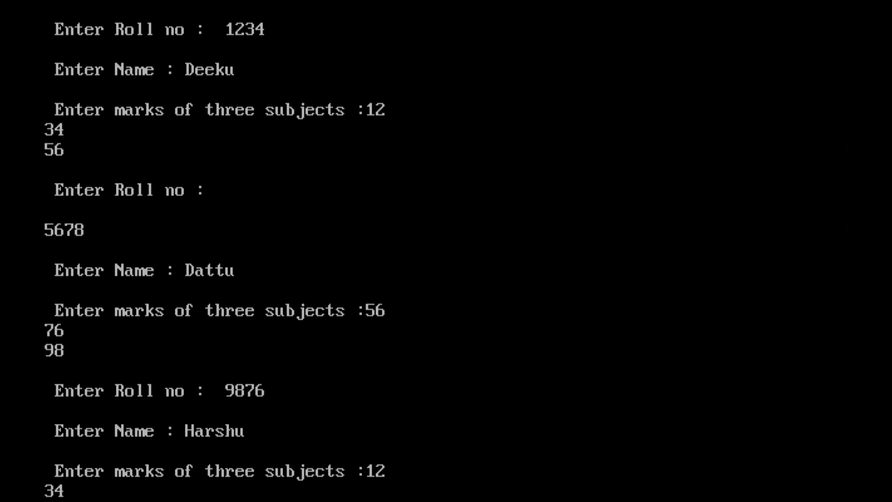

1. Declare two structures one called employee: Name, address, phone number, salary and the second is called perks: Da =20% of salary, Hra=25% of salary, Net =salary+da+hra. Write a program to calculate net salary of an employee.

**INPUT:**

#include<iostream.h>

#include<conio.h>

#include<stdio.h>

struct employee

{

char Name[25],address[80],ph[11];

long Salary;

}s;

struct perks

{

float da ,hra,net;

}p;

void main ()

{

clrscr();

cout << "\nEnter Employee Name : ";

gets(s.Name);

cout << "\nEnter Employee Address : ";

gets(s.address);

cout << "\nEnter Employee Phone Number: ";

gets(s.ph);

cout << "\nEnter Employee Salary : ";

cin >> s.Salary;

p.da = 0.2 * s.Salary;

p.hra = 0.25 * s.Salary;

p.net = p.da + p.hra + s.Salary;

cout << "\nEmployee Name : " << s.Name;

cout << "\nEmployee Net Salary : " << p.net;

getch();

}

**OUTPUT:**

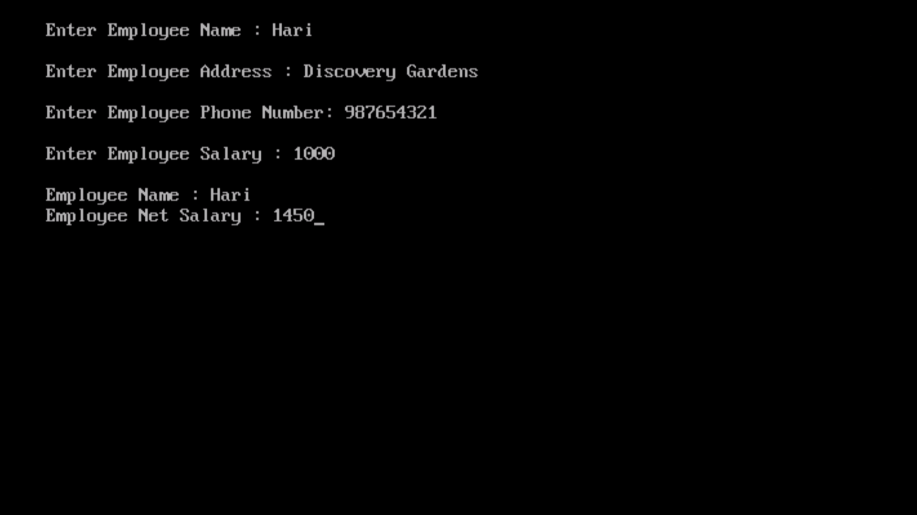

1. Details of 50 clients of an investment company are stored in an array of structures. Details include customers name, code, date of starting, number of years, interest rate and total amount. Write a program to calculate compound interest for these clients.

**INPUT:**

#include<math.h>

#include<stdio.h>

#include<conio.h>

#include<iostream.h>

struct client_info

{

char name[50];

int code;

double d_o_s;

double year;

double rate;

double amount;

};

client_info client[50];

void main()

{

int i,j;

double compound,x;

for(i=0;i<50;i++)

{

cout<<"enter customer name = ";

gets(client[i].name);

cout<<"enter code = ";

cin>>client[i].code;

cout<<"enter date of starting = ";

cin>>client[i].d_o_s;

cout<<"enter number of years = ";

cin>>client[i].year;

cout<<"enter interest rate = ";

cin>>client[i].rate;

cout<<"enter total amount =";

cin>>client[i].amount;

x= client[i].amount*pow(( 1.0+client[i].rate/100.0),

client[i].year);

compound=x-client[i].amount;

}

for(i=0;i<50;i++)

{

cout<<" customer name = "<<client[i].name<<endl;

cout<<"code = "<<client[i].code<<endl;

cout<<"date of starting = "<<client[i].d_o_s<<endl;

cout<<"number of years = "<<client[i].year<<endl;

cout<<"intrest rate = "<<client[i].rate<<endl;

cout<<"total amount ="<<client[i].amount<<endl;

cout<<"compound intrest ="<<compound<<endl;

}

getch();

}

**OUTPUT:**

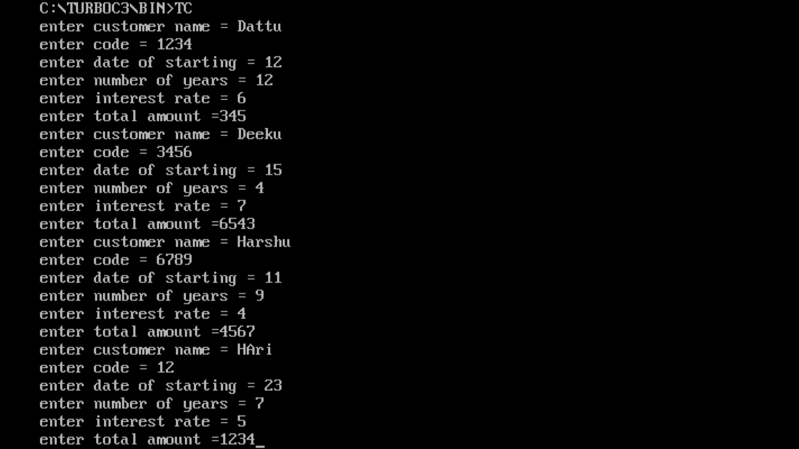

1. Write a program in C++ using function to display those elements of a two dimensional array M[5][5] which are divisible by 10. Assume the content of the array is already present and the function prototype is as follows: - void display10 (int M [5][5]).

**INPUT:**

#include<iostream.h>

#include<conio.h>

void display10(int M[5][5])

{

int b[50],i,j,k=0;

for(i=0;i<5;i++)

{

for(j=0;j<5;j++)

{

if(M[i][j]%10==0)

{

b[k]=M[i][j];

k++;

}

}

}

cout<<"\nThe resultant 1D array is :";

for(i=0;i<k;i++)

{

if(b[i]>0)

cout<<b[i]<<" ";

}

}

void main()

{

clrscr();

int a[5][5]={10,11,12,34,20,45,80,75,23,100,40,65,32,90};

display10 (a);

getche();

}

**OUTPUT:**

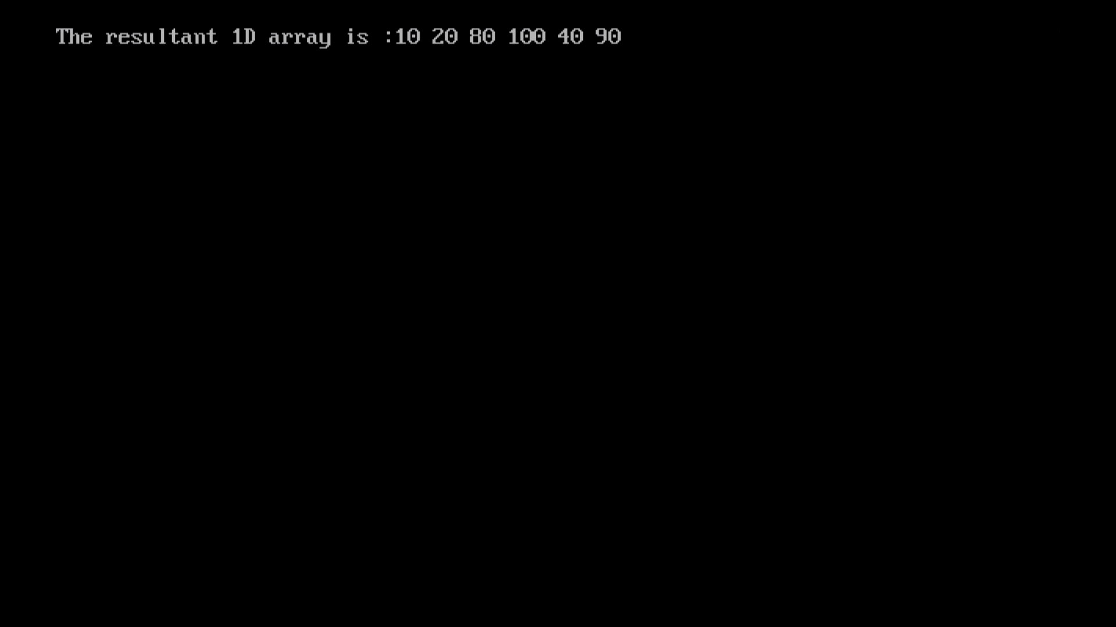

1. Declare a structure distance having feet and inches. Write a C++ program to add two distances.

**INPUT:**

#include<iostream.h>

#include<conio.h>

#include<stdio.h>

struct Distance{

int feet;

int inch;

}d1 , d2, sum;

void main()

{

clrscr();

cout << "Enter 1st distance," << endl;

cout << "Enter feet: ";

cin >> d1.feet;

cout << "Enter inch: ";

cin >> d1.inch;

cout << "\nEnter information for 2nd distance" << endl;

cout << "Enter feet: ";

cin >> d2.feet;

cout << "Enter inch: ";

cin >> d2.inch;

sum.feet = d1.feet+d2.feet;

sum.inch = d1.inch+d2.inch;

while (sum.inch >= 12)

{

sum.feet ++;

sum.inch -= 12;

}

cout << endl << "Sum of distances = " << sum.feet << " feet " << sum.inch << " inches";

getche();

}

**OUTPUT:**

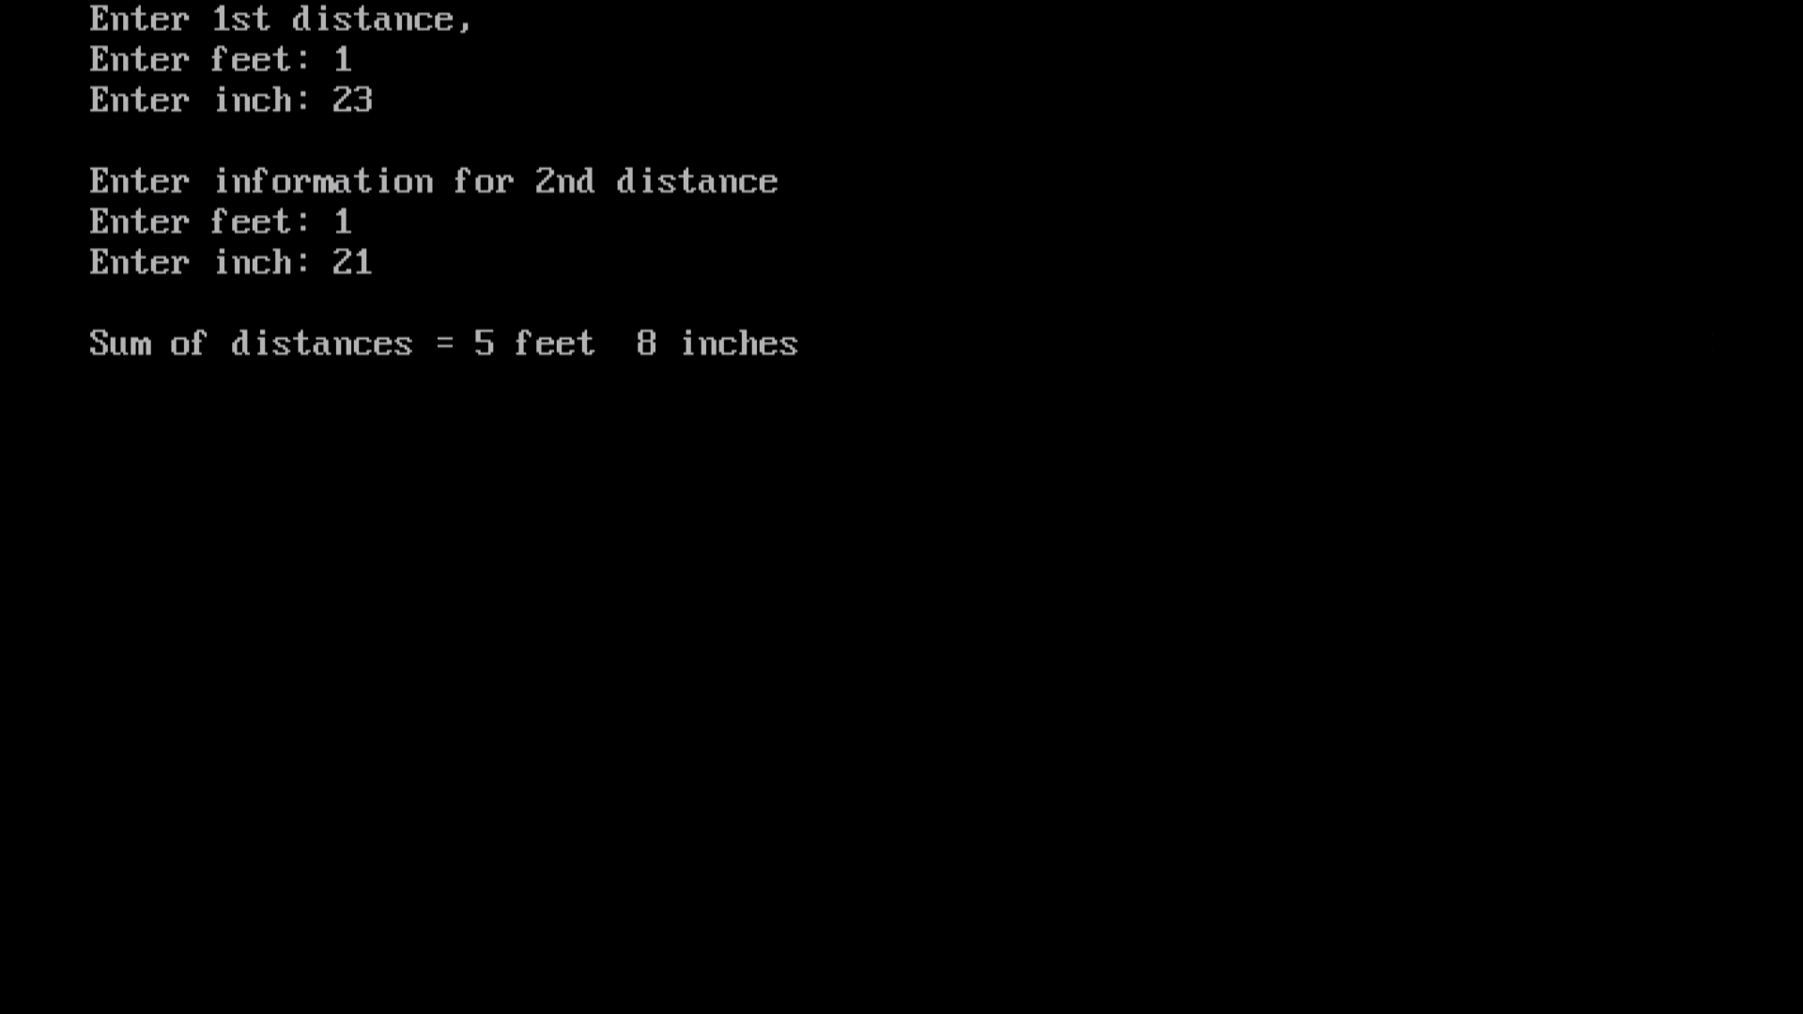

6. A linear array of size 10 stores following information: name of the country, country’s capital and per capita income of the country. Write a complete program in C++ to do the following:

a) To read a country’s name and display capital and per­capita income.

b) To read name of the capital city and display country’s name and per capital income. Display an error message in case of an incorrect input.

**INPUT:**

#include<iostream.h>

#include<conio.h>

#include<stdio.h>

#include<string.h>

struct country

{

char nm[30];

char capital[30];

float income;

};

void main()

{

clrscr();

country c[10];

for( int i=0; i<10 ; i++)

{

cout << "\n Country's name : ";

gets(c[i].nm);

cout << "\n Country's capital :";

gets(c[i].capital);

cout << "\n Per capita income :";

cin >> c[i].income;

}

clrscr();

cout << "\n\n Sl No. \t Country \t Capital \t Per-Ca pita-Income \n :";

for( i=0; i < 10 ; i++)

{

cout << i+1 << "\t" << c[i].nm << "\t" << c[i].capital << "\t" << c[i].income << "\n" ;

}

char ch = 'y';

char cap[30];

int flag = 0;

while(ch == 'y' || ch == 'Y')

{

cout << "\n Enter Capital name : ";

cin.getline(cap, 30);

for(int k =0; k <10 ; k++)

{

flag = 0;

if( strcmp( c[i].capital , cap ) == 0)

{

cout << c[i].nm << "\t" << c[i].capital << "\t" << c[i].income << "\n" ;

flag = 1;

}

if(flag == 0)

cout << " Match not found !! ";

cout<< "Do you want to continue ?(y/n)";

cin >> ch;

}

}

getche();

}

**OUTPUT:**

